Members:

Nguyễn Trung Nguyên - 20127404

Phạm Huy Cường Thịnh - 20127335

Lê Đặng Minh Khôi - 20127213

Nguyễn Phượng Khanh - 20127204

Nguyễn Bùi Hoàng Lam - 20127223

UI Prototype

1. User View
   1. Homepage/Top movies

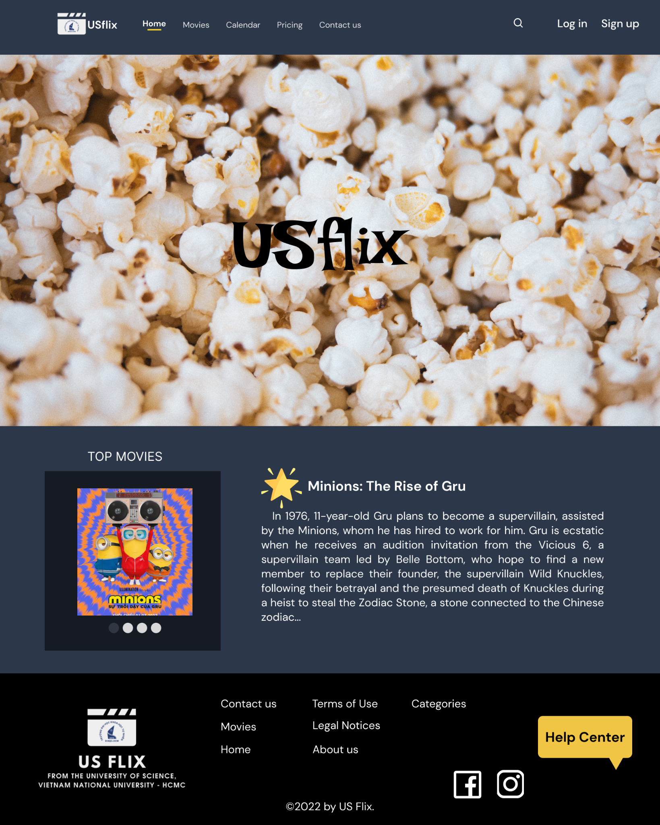

When people check in to our website, they will see this screen. Users can view a navigation bar at the top of the screen with components such as Home, Movies, Calendar, Pricing, Contact us, Sign-up button, Log-in button. Users may check the top movies that are currently popular by scrolling down. Users can also view extra component buttons, company information, copyrights, forms, and so on under the screen's footer. Users can view the most popular movies available on the website.

* 1. Sign up

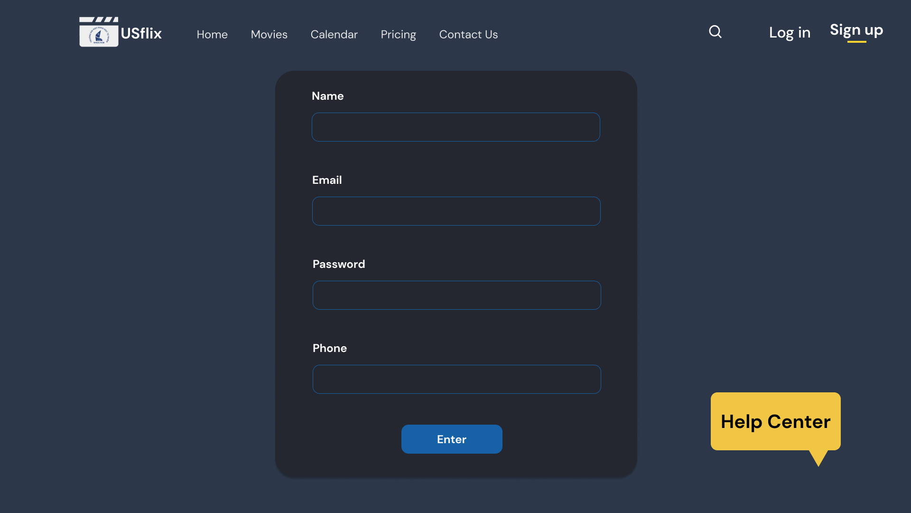

In order to register, users must fill out the Name, Email, Password, and Phone Number sections on this screen. After that they can press the Enter button.

* 1. Log in

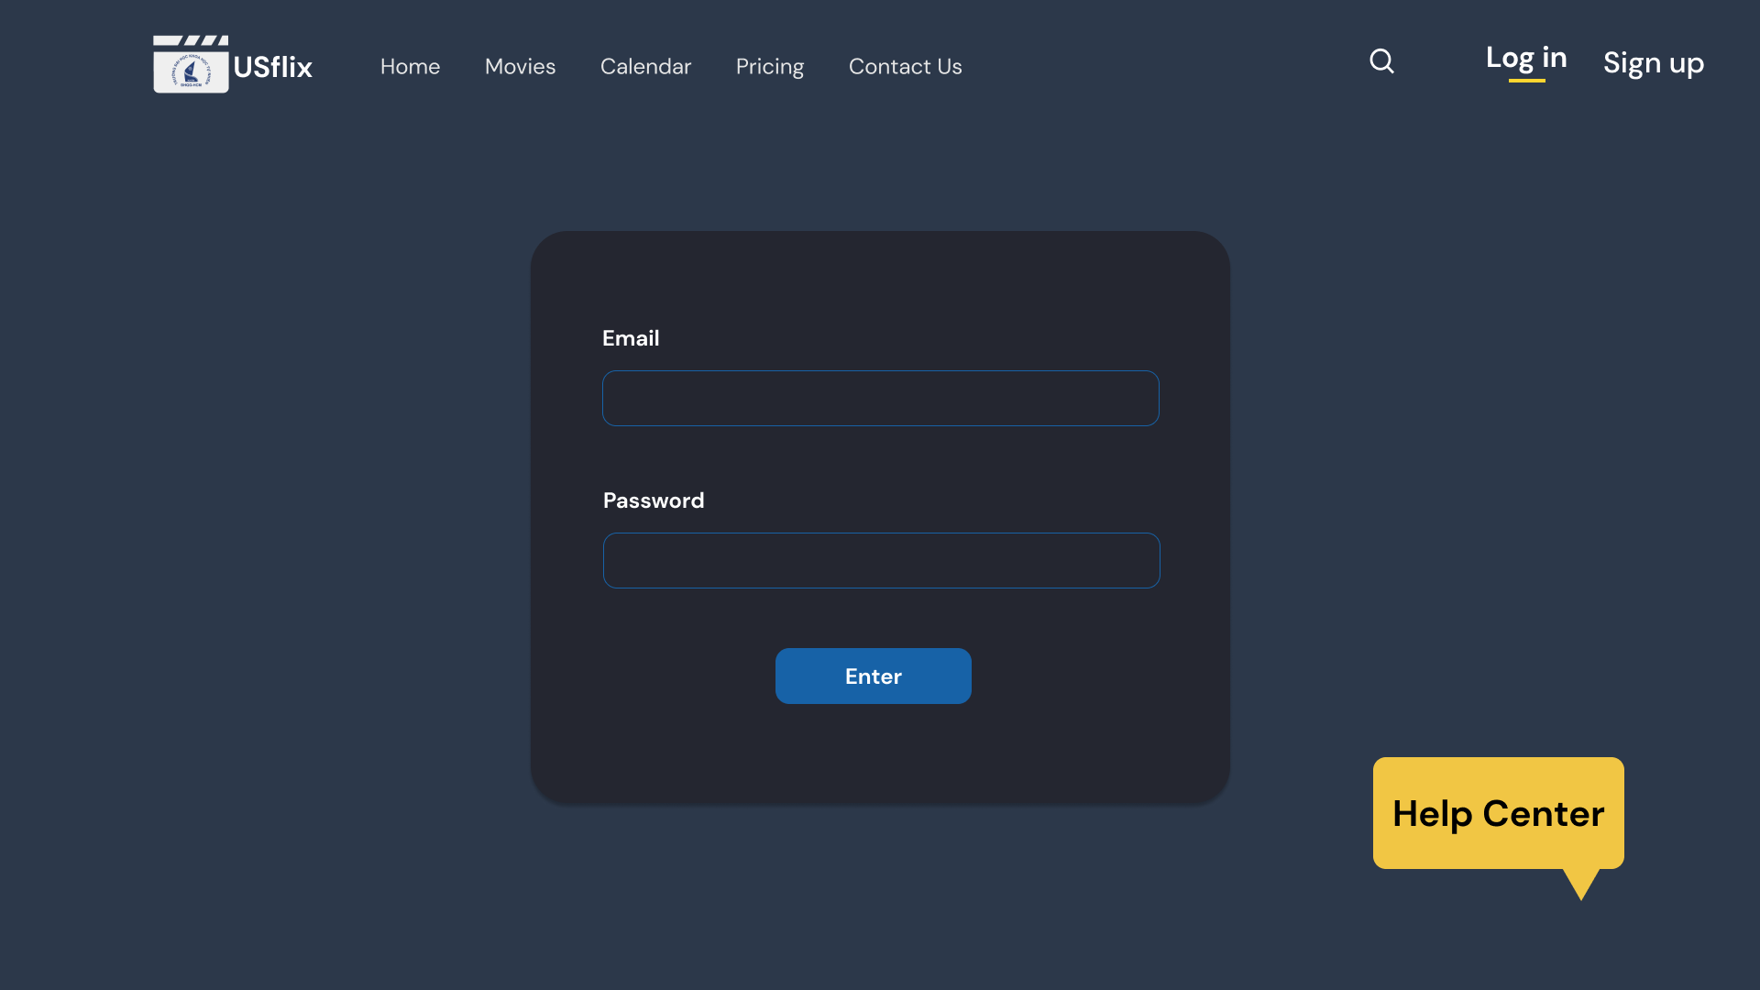

On this screen, users can log in by entering their email address and password.

If the user enters wrong information, the system will show “Email or password is wrong” and continue to show the Log-in page.

* 1. Edit user information

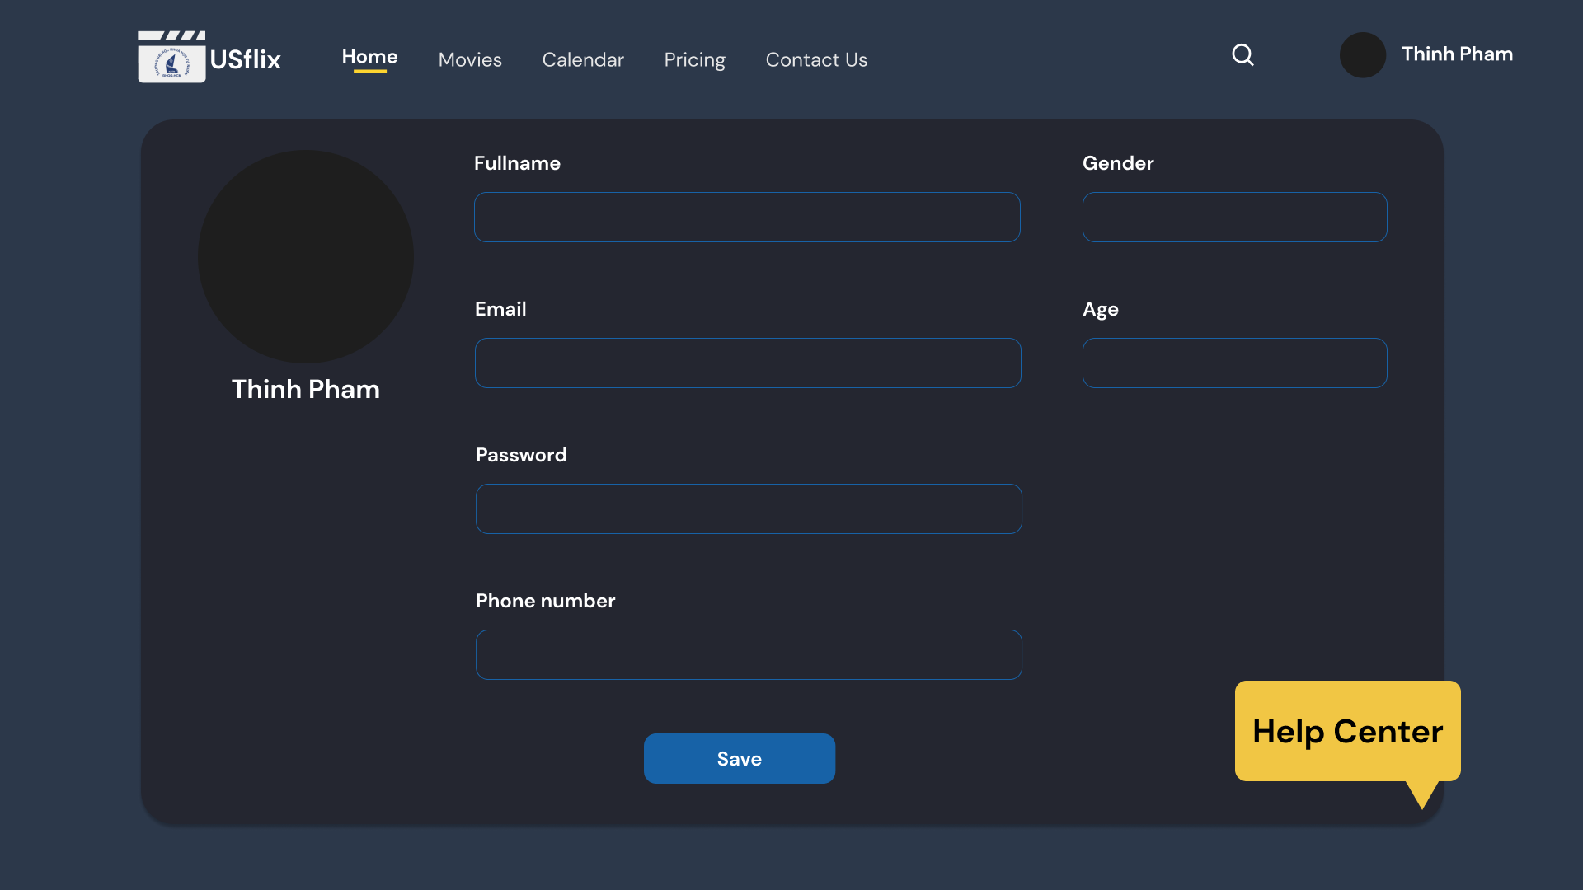

Users can update their personal information on this screen, including their name, email address, password, phone number, and the addition of their gender and age. After that they can press the Enter button.

* 1. Edit Favorites section

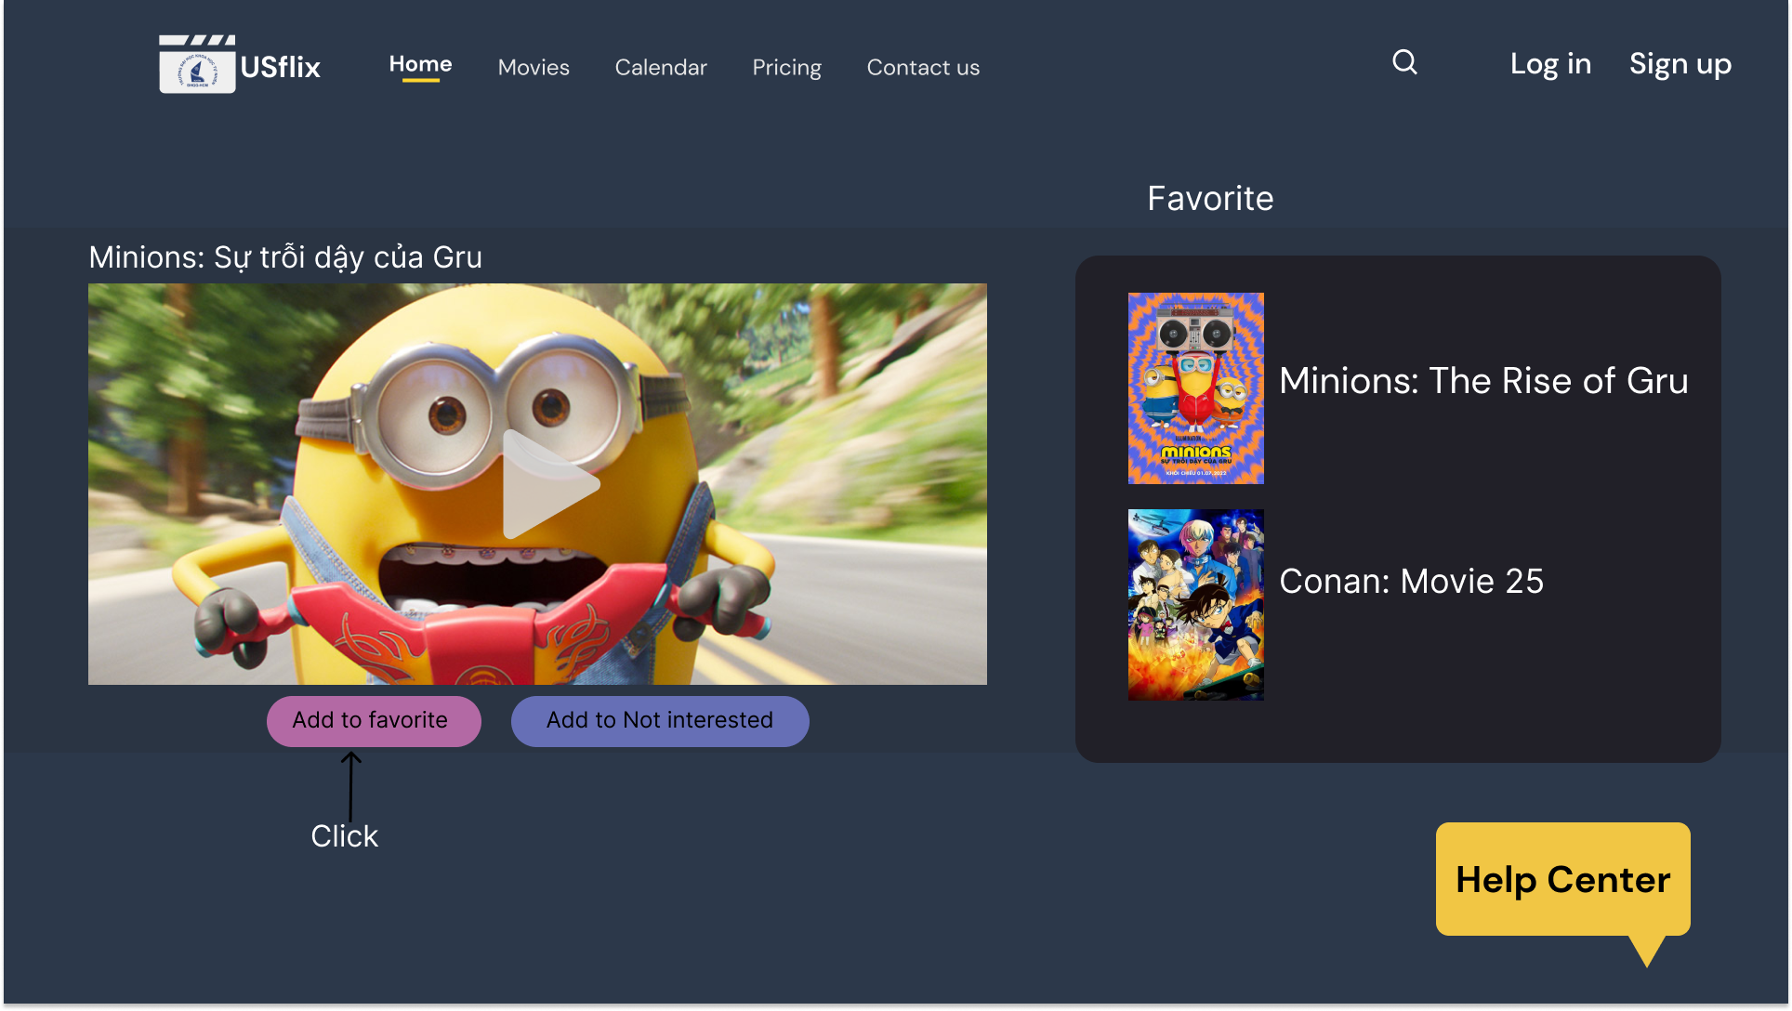

Users can add a movie or many movies to their Favorites list on this screen so they can watch them again or suggest them to friends or other users.

* 1. Edit Not interested section

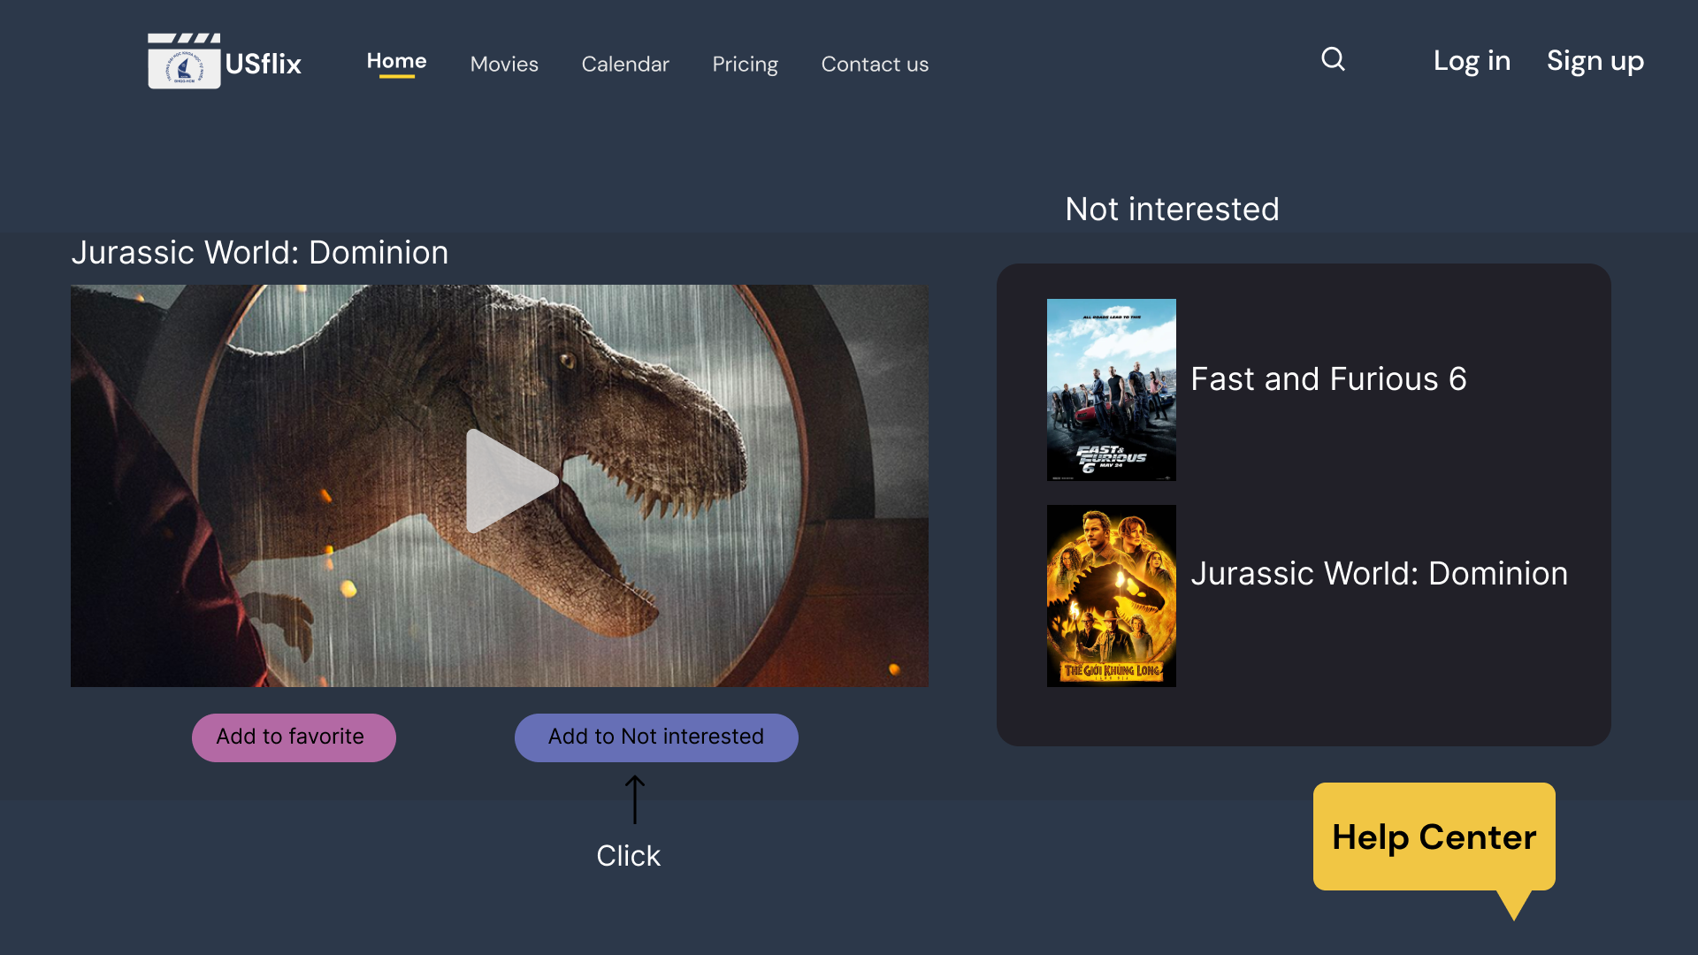

Users can add a movie or many movies to the Not Interested list on this screen, preventing them from seeing that film in the future.

* 1. Pricing

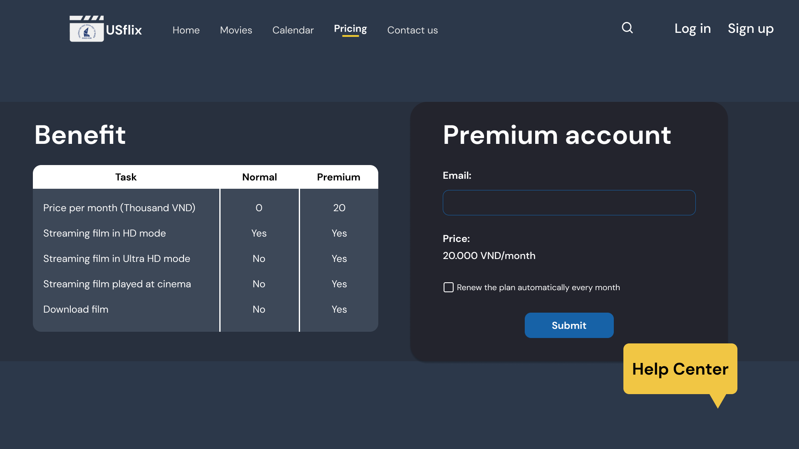

Users may explore the benefits of a Premium Account on this screen and upgrade their account to a Premium Account by entering their email address. They can also renew their plan each month once it expires.

* 1. Watch the trailer

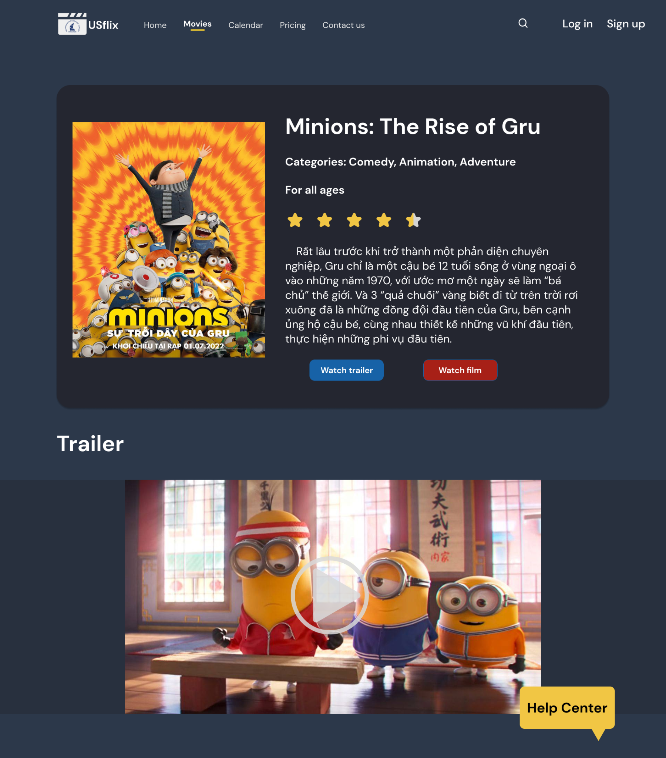

On this page, the viewer can see detailed information about the film, such as the title, categories, age restrictions, star ratings, and so on.

The user selects Watch trailer/scrolls the page and clicks the Play button on the trailer to view the film's trailer.

* 1. Streaming film

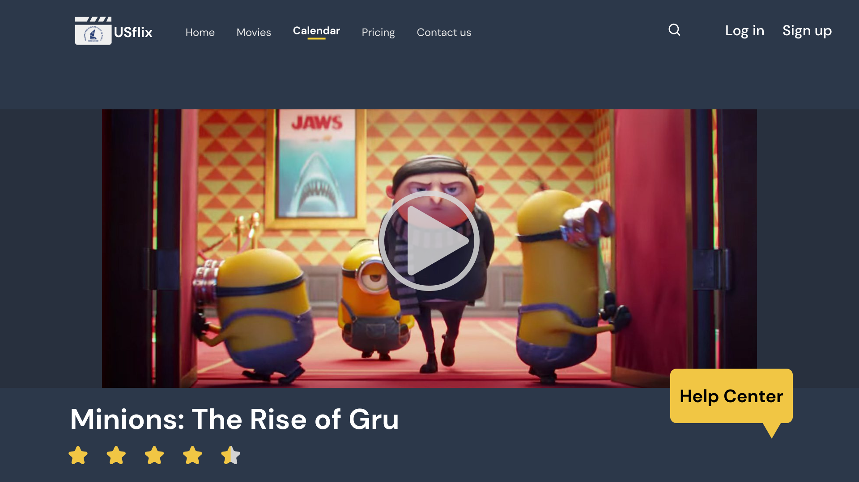

On this screen, users can watch a movie by clicking the Play button.

Users can rate a film's star by clicking on the rating stars.

* 1. Calendar

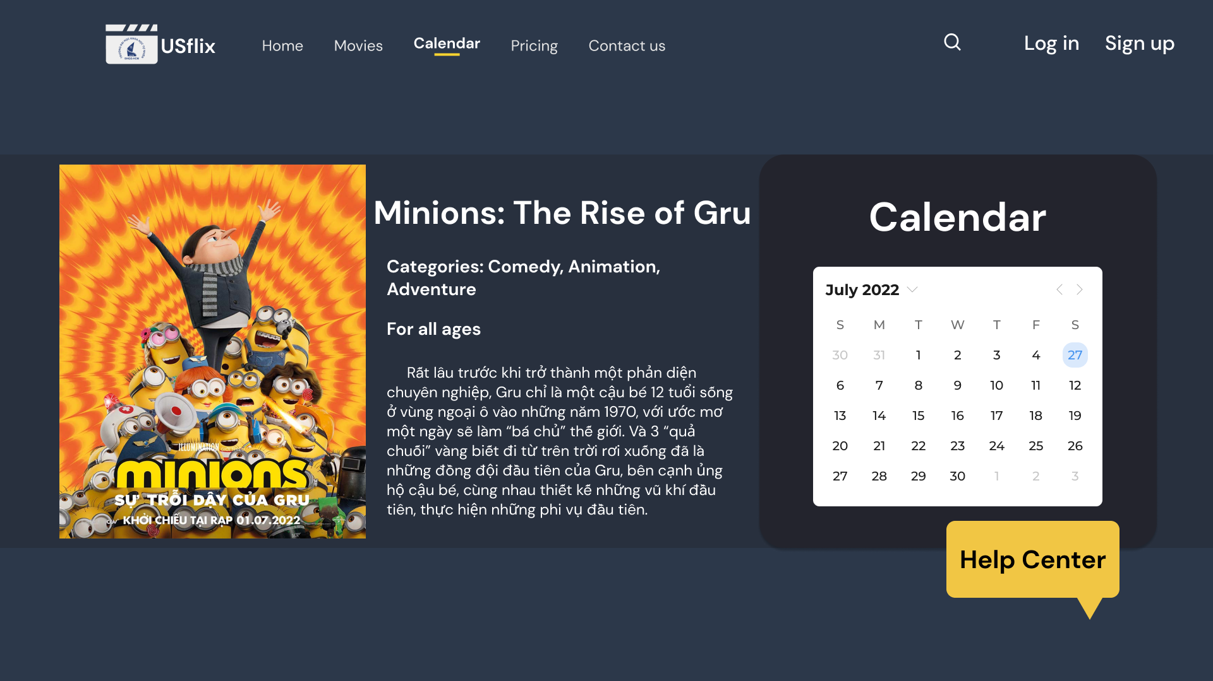

On this page, users can check upcoming movie schedules by clicking on a calendar day and then clicking on the same day again to cancel the selection.

On the left side of the calendar, the system will display information about the film and its poster.

The user selects another month by clicking the left/right arrow.

* 1. Contact us

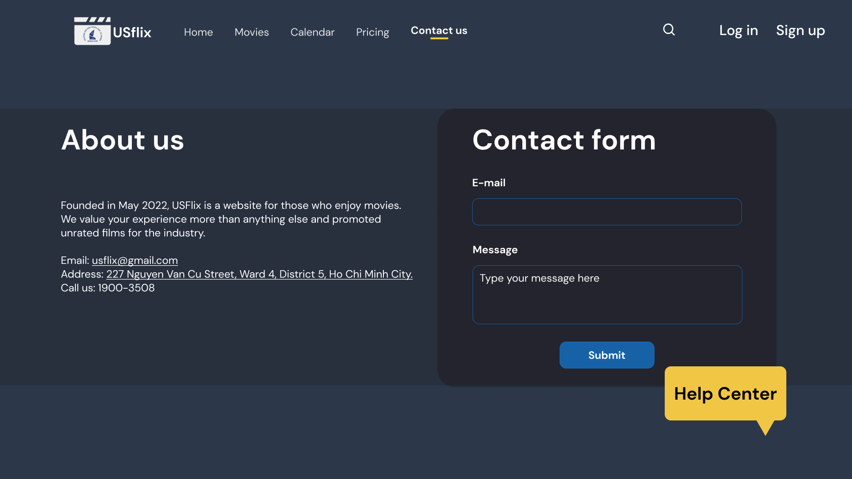

Users can contact us by providing their email address and message, then clicking the Submit button.

Admin will receive the form and reply as soon as they can by email.

* 1. Help Center

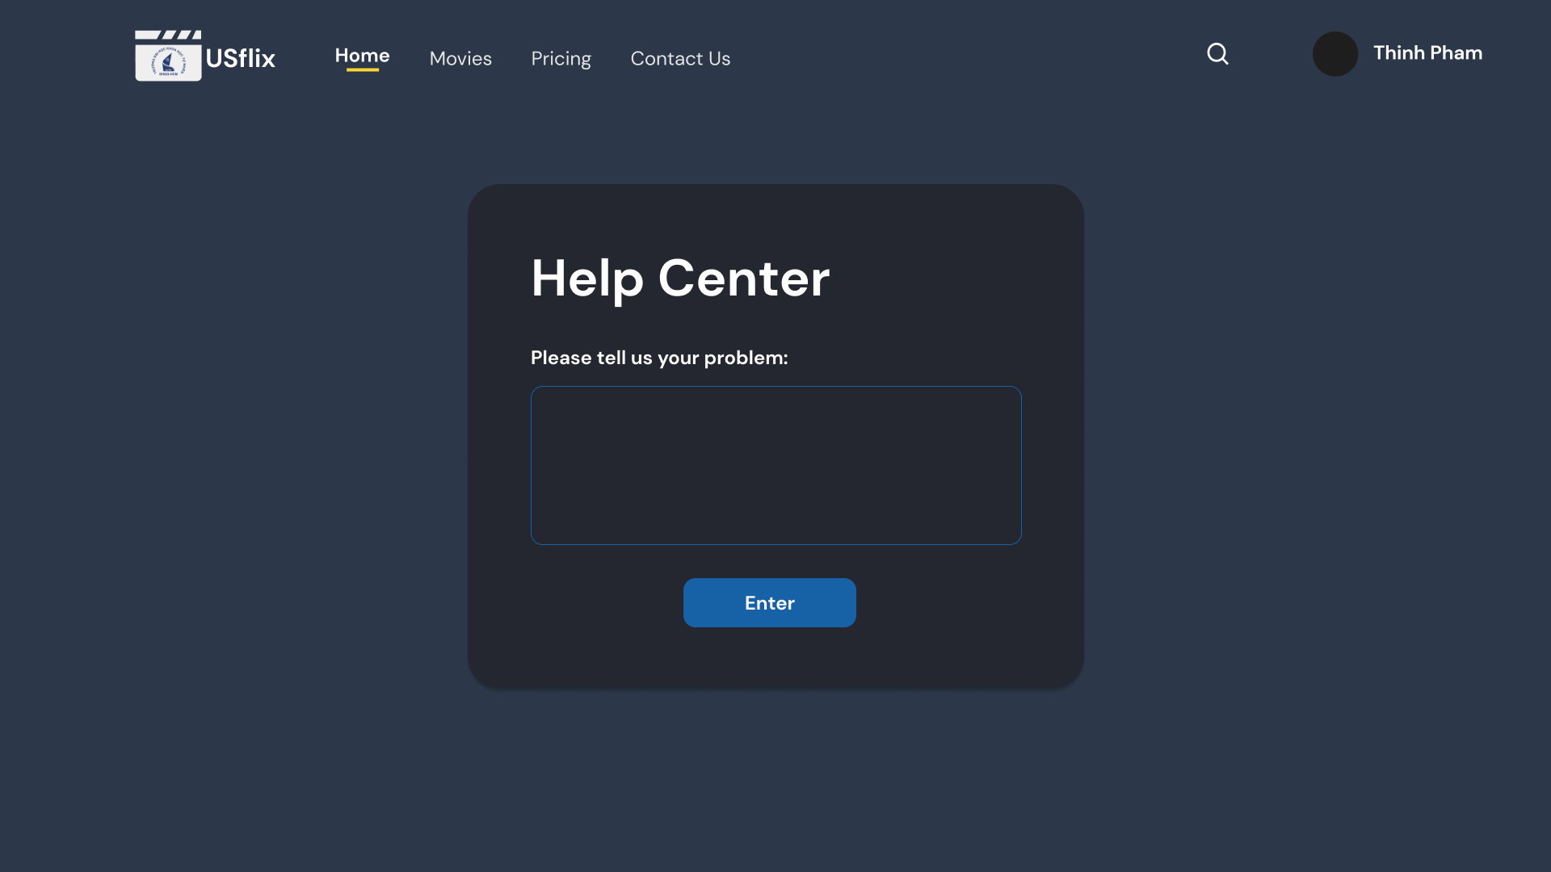

When the user clicks the Help Center button to get help on any page, they will be navigated to the Help Center page. The user writes their problem into a blank box, then submits by clicking the Enter button.

The Customer Care Team can contact the user quickly to assist and improve the user experience when using website services.

1. Administrator View
2. Log in

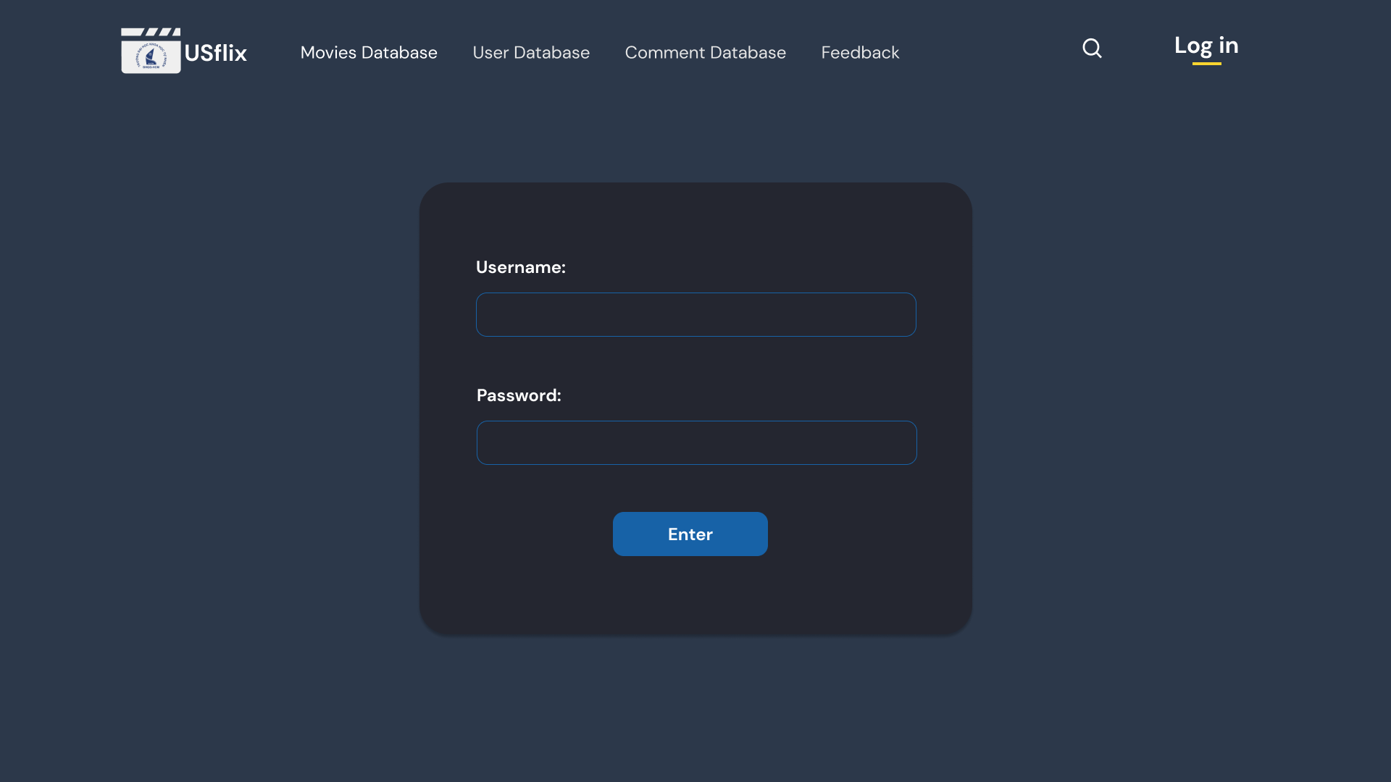

On this screen, administrators can log in by entering their email address and password.

If the password or username is wrong the system will pop-up an error notification.

1. Edit Movies Database

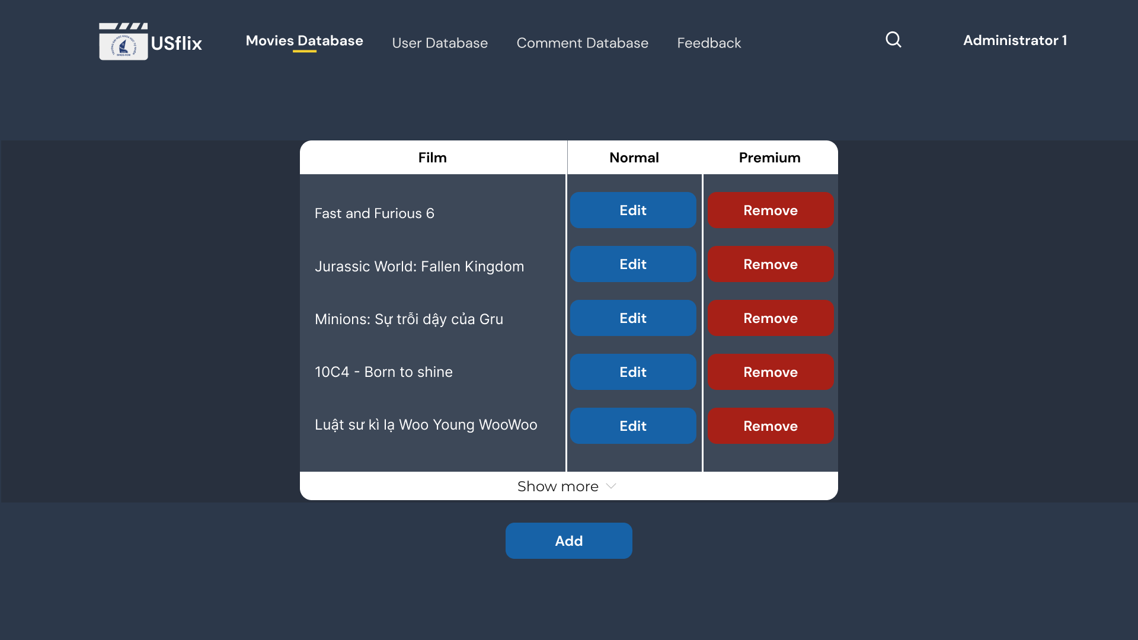

Admin can remove/add films from the list by clicking the Remove/Add button.

Admin edit film information by clicking the Edit button, and the system will navigate to the Edit Movies Information page. Admin can expand the list by clicking Show-more.

1. Edit Movies Information.

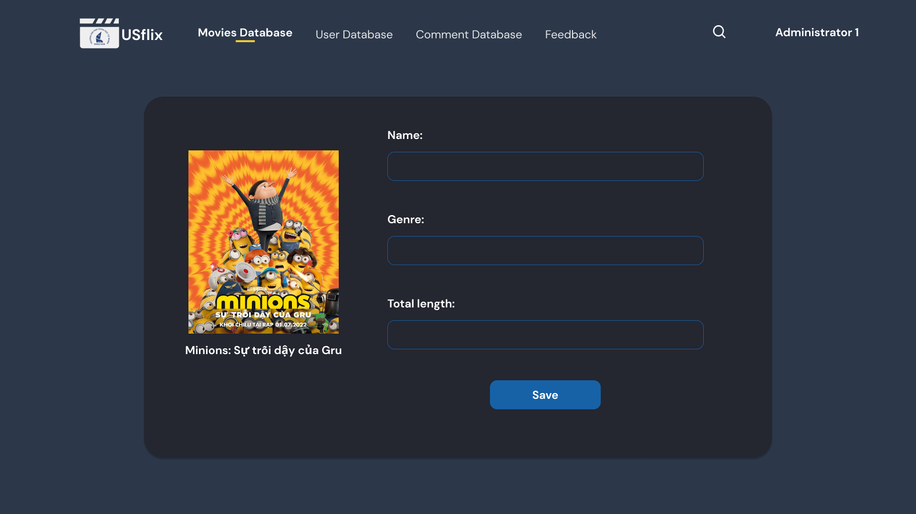

Admin will update film information by filling in the blanks and pressing the Save button after editing.

1. Delete User’s comment.

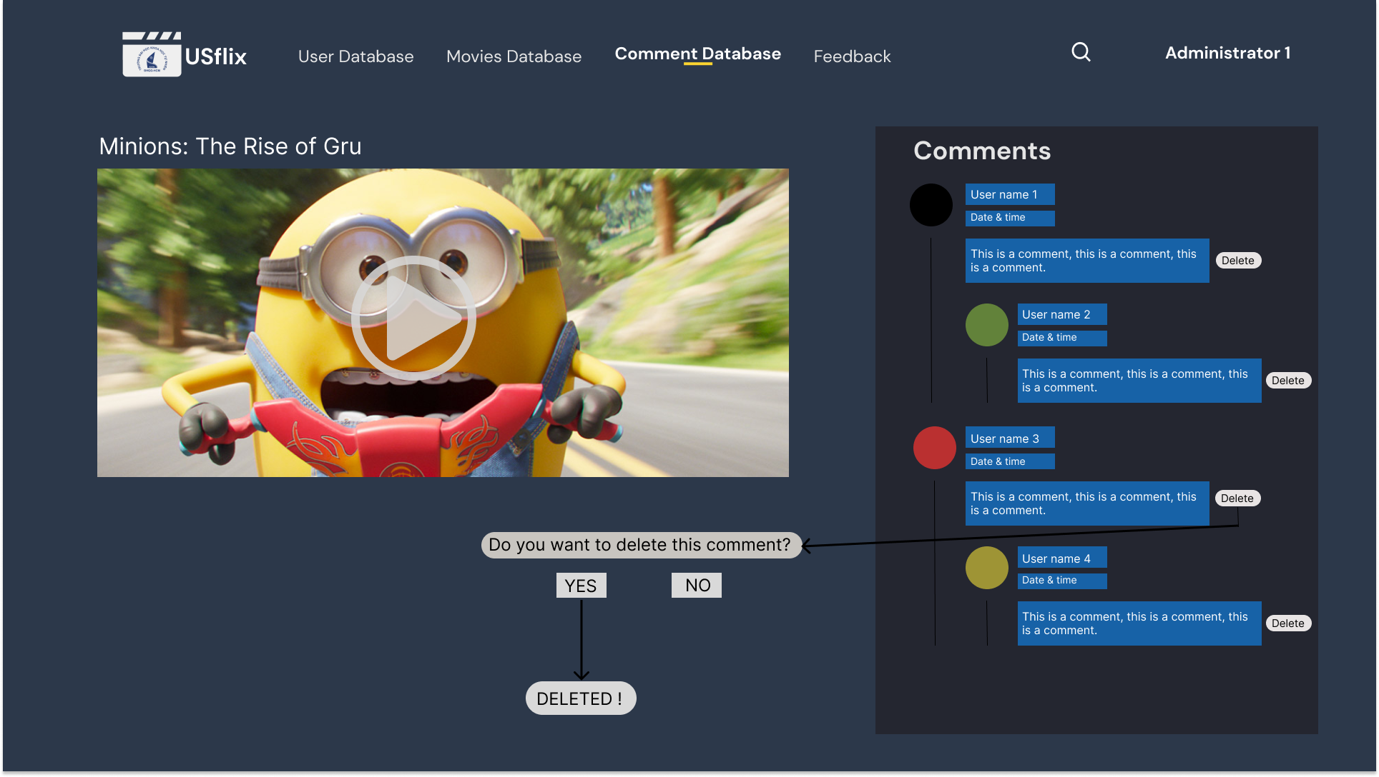

If a user's comment violates community guidelines, the administrator has the right to remove it without notification by clicking their comments and pressing the Delete button.

1. Remove a user account.

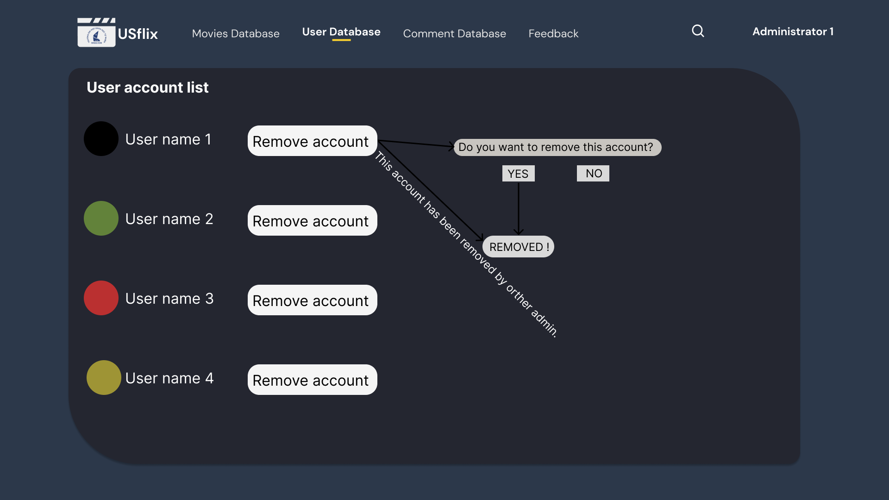

Admin can remove a user account or many user accounts from the user account list by clicking their accounts and press the Remove button.

1. See user feedback.

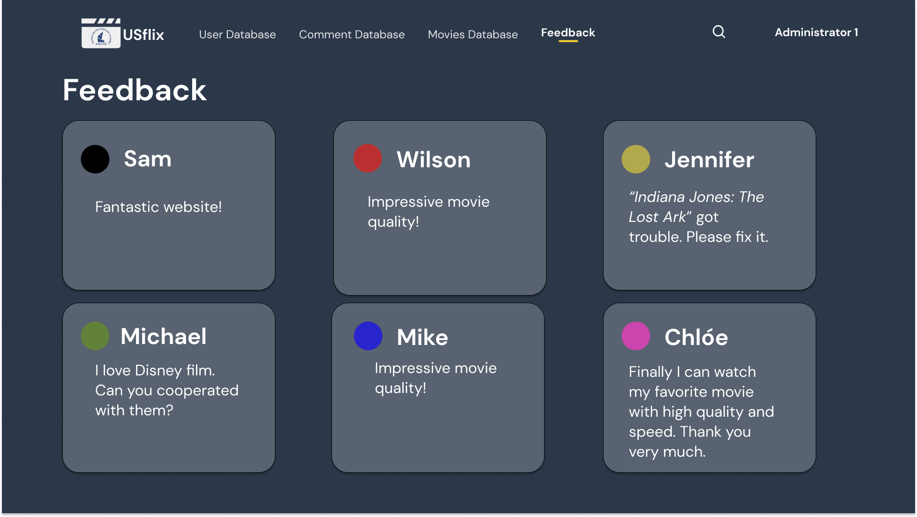

By clicking the Feedback component, admin can read feedback from other users to help the user immediately.